

**1**

Low Level Design

Amazon Sales Data Analysis

Date of revision: 12/7/2024

Neel Gokhale

**Document Version Control**



**2**

|  |  |  |  |
| --- | --- | --- | --- |
| **Date Issued** | **Version** | **Description** | **Author** |
| **12th July 2024** | 1.0 | First Version of Complete LLD | Neel Gokhale |
|  |  |  |  |
|  |  |  |  |
|  |  |  |  |
|  |  |  |  |
|  |  |  |  |
|  |  |  |  |

### 3



Contents

1. Introduction 4
   1. What is Low-Level design document? 4
   2. Scope 4
2. Architecture 5
3. ARCHITECTURE DESCRIPTION 7
   1. Data Description 7
   2. Data Loading 8
   3. Data Transformation 9
   4. Data Modelling 9
   5. Data analysis and visualization 9
   6. Deployment 9
4. UNIT TEST CASES 10

# Introduction



**4**

## What is Low-Level design document?

The goal of the LDD or Low-level design document (LLDD) is to give the internal logic design of the actual program code for the House Price Prediction dashboard. LDD describes the class diagrams with the methods and relations between classes and programs specs. It describes the modules so that the programmer can directly code the program from the document.

## Scope

Low-level design (LLD) is a component-level design process that follows a step-by-step refinement process. The process can be used for designing data structures, required software architecture, source code and ultimately, performance algorithms. Overall, the data organization may be defined during requirement analysis and then refined during data design work.

# Architecture



**5**

Tableau is a powerful data visualization and business intelligence software tool that allows users to easily connect, visualize, and share data in interactive and engaging ways. Some of the popular Tableau software tools are:

1. Tableau Desktop: This is the main authoring and publishing tool of Tableau that allows users to create interactive dashboards, reports, and charts using a drag-and-drop interface.
2. Tableau Prep: This is a data preparation tool that enables users to clean, shape, and combine their data before visualizing it in Tableau Desktop.
3. Tableau Server: This is a web-based platform that allows users to publish and share their Tableau dashboards and reports with others within their organization.
4. Tableau Online: This is a cloud-based version of Tableau Server that enables users to access and share their Tableau content from anywhere with an internet connection.
5. Tableau Public: This is a free, public-facing platform that allows users to publish and share their Tableau visualizations with the world.
6. Tableau Mobile: This is a mobile app that allows users to view and interact with Tableau dashboards and reports on their mobile devices.

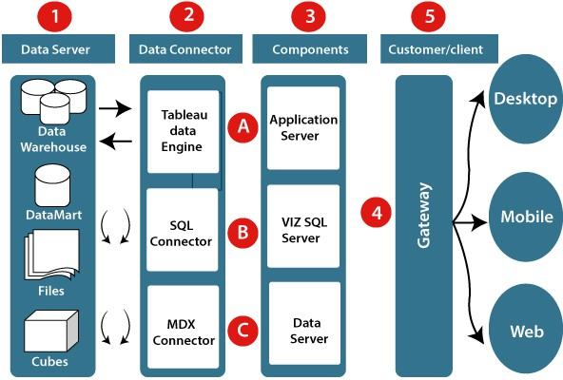

### Data server

The primary component of Tableau Architecture is the Data sources which can connect to it.

Tableau can connect with multiple data sources. It can blend the data from various data sources. It can connect to an **excel file, database**, and a **web application** at the same time. It can also make the relationship between different types of data sources.



**6**

**2. Data connector**

The Data Connectors provide an interface to connect external data sources with the Tableau Data Server.

Tableau has in-built SQL/ODBC connector. This ODBC Connector can relate to any databases without using their native connector. Tableau desktop has an option to select both extract and live data. On the uses basis, one can be easily switched between live and extracted data.

* + **Real-time data or live connection:** Tableau can relate to real data by linking to the external database directly. It uses the infrastructure existing database by sending dynamic **multidimensional expressions (MDX)** and SQL statements. This feature can be used as a linking between the live data and Tableau rather than importing the data. It makes optimized and a fast database system. Mostly in other enterprises, the size of the database is large, and it is updated periodically. In these cases, Tableau works as a front-end visualization tool by connecting with the live data.
  + **Extracted or in-memory data:** Tableau is an option to extract the data from external data sources. We make a local copy in the form of Tableau extract file. It can remove millions of records in the Tableau data engine with a single click. Tableau's data engine uses storage such as **ROM, RAM**, and **cache** memory to process and store data. Using filters, Tableau can extract a few records from a large dataset. This improves performance, especially when we are working on massive datasets. Extracted data allows the users to visualize the data offline, without connecting to the data source.

### Components of Tableau server

Different types of components of the Tableau server are:

* + Application server
  + VizQL server
  + Data server

### Application server

The application server is used to provide the authorizations and authentications. It handles the permission and administration for mobile and web interfaces. It gives a guarantee of security by recording each session id on Tableau Server. The administrator is configuring the default timeout of the session in the server.

### VizQL server

VizQL server is used to convert the queries from the data source into visualizations. Once the client request is forwarded to the VizQL process, it sends the query directly to the data source retrieves information in the form of images. This visualization or image is presented for the users. Tableau server creates a cache of visualization to reduce the load time. The cache can be shared between many users who have permission to view the visualization.

### Data server

### 7



Data server is used to store and manage the data from external data sources. It is a central data management system. It provides **data security, metadata management, data connection, driver requirements**, and data storage. It stores the related details of data set like **calculated fields, metadata, groups, sets**, and **parameters**. The data source can extract the data as well as make live connections with external data sources.

### Gateway

The gateway directed the requests from users to Tableau components. When the client sends a request, it is forwarded to the external load balancer for processing. The gateway works as a distributor of processes to different components. In case of absence of external load balancer, the gateway also works as a load balancer. For single server configuration, one gateway or primary server manages all the processes. For multiple server configurations, one physical system works as a primary server, and others are used as worker servers. Only one machine is used as a primary server in Tableau Server environment.

### Clients

The visualizations and dashboards in Tableau server can be edited and viewed using different clients. Clients are a web browser, mobile applications, and Tableau Desktop.

* + **Web Browser:** Web browsers like **Google Chrome, Safari**, and **Firefox** support the Tableau server. The visualization and contents in the dashboard can be edited by using these web browser.
  + **Mobile Application:** The dashboard from the server can be interactively visualized using mobile application and browser. It is used to edit and view the contents in the workbook.
  + **Tableau Desktop:** Tableau desktop is a business analytics tool. It is used to **view, create**, and **publish** the dashboard in Tableau server. Users can access the various data source and build visualization in Tableau desktop.

# ARCHITECTURE DESCRIPTION

## Data Description

##### The dataset contains two tables Customer and Sales data of Amazon for the year 2017,2018,2019

#### Amazon Sales Data Features

##### Custkey – It is a Unique Id used to define a customer.

##### Datekey – It is the date on which transaction took place.

##### Discount amount – It is the difference between Sales amount based on list price and Sales amount.

##### Invoice Date – It is the date on Which the Ordered delivered and invoice created.

##### Invoice Number – It is a Unique number generated by the system after making of invoice

##### Item Class – It is the class of the Item.

##### Item Number – It is a Unique number used to define an item.

##### Item – It is the name of the item for which transaction took place.

##### Line Number – It is the number of line from which it is ordered.

### 8



##### List Price – It is the price quoted by the manufacturer.

##### Order Number – It is the Unique Number for the particular order.

##### Promised delivery date – It is the date provided on which delivery is expected.

##### Sales Amount – It is the Product of Sales Price and Quantity.

##### Sales amount based on List Price – It is the product of List price and Quantity.

##### Sales Cost amount – It is the amount caused for making sales of the item.

##### Sales Margin amount - It is the difference between Sales amount and Sales cost amount.

##### Sales Price – It is the price at which Item is Sold.

##### Sales Quantity – It is the quantity of the ordered item.

##### Sales Rep. – It is the unique number or Id of the sales representative.

##### U/M – It Is the Unit of measurement for particular item.

#### Customer Details Data Features

##### Custkey – It is a Unique Id used to define a customer.

##### Region Name – for eg central, southern etc.

##### Division Name – Domestic or international

##### City – Name of city

##### Country – Name of country

##### Zip Code – zip code for city.

##### Customer Name – It is a Customer name

## Data Loading

Step 1: - Open Tableau Desktop Application.

Step 2: - Get data by clicking connect from MS Excel.

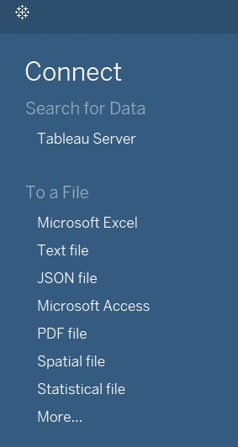

Step 3: - Browse to the data file on your system and select

### 9



## Data Transformation

In the Transformation Process, we will convert our original datasets with other necessary attributes format and change the features according to the problem statement.

A new date table created for easy time intelligence analysis the features are:

1. Day of Week
2. Month name 3.Year
3. Year quarter
4. Month
5. Date

## Data Modelling

After the data is transformed the data is modeled for visualizing and analysis.

## Data analysis and visualization

Analyzed and Visualized the Data.

## Deployment

Dashboard is published on Tableau public platform.

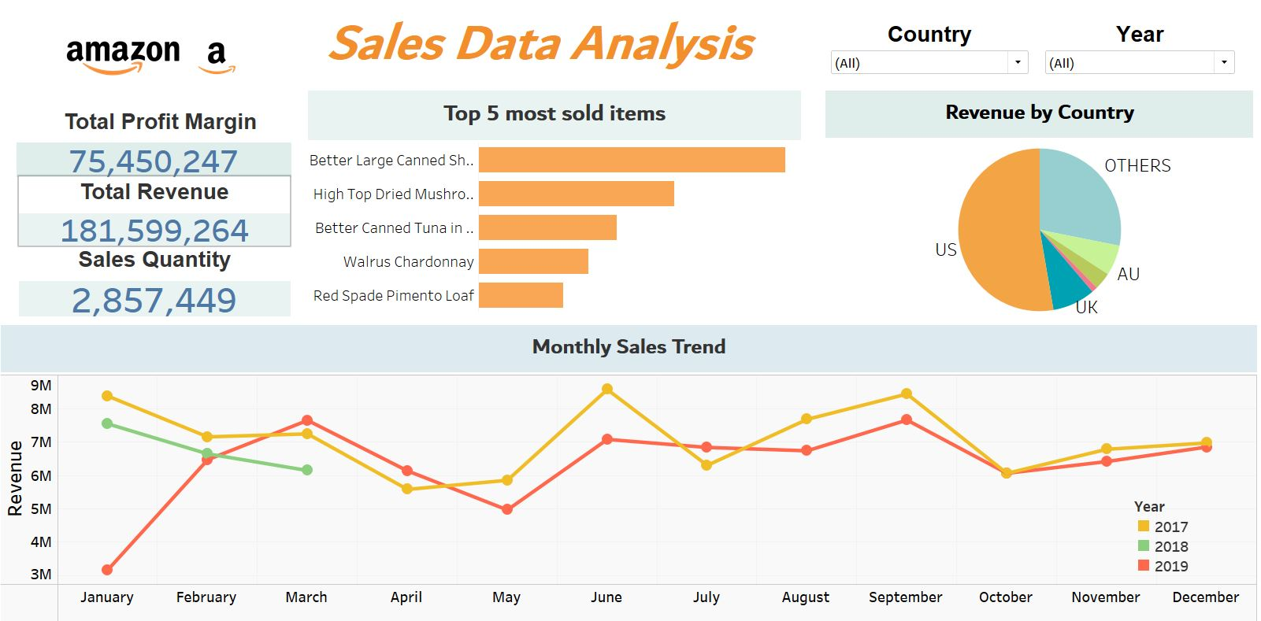

# UNIT TEST CASES



**10**

|  |  |
| --- | --- |
| **Test Case** | **Description** |
| **Slicer of Year & Country.** | Slicer shows a drop down |
| **Charts** | All charts showing 0 error |
| **Tooltips** | Tooltips on various page working properly |
| **Page buttons** | Page buttons working properly |